Query 1:

Command:

SELECT \*

FROM customers

where CustState = 'WA';

Screenshot:

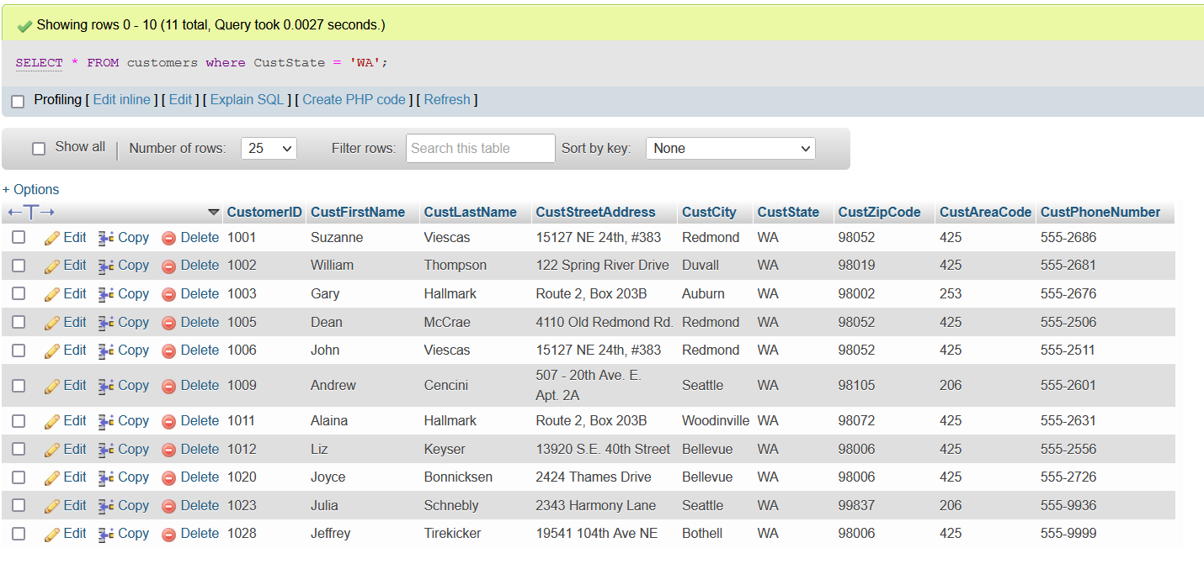

Query 1:

Command:

SELECT \*

FROM customers

where CustState = 'WA' or CustState = 'OR' ;

(please turn over to see the screenshot)

Screenshot:

